When I found *Dr. Kermit W. Sprocket’s Build Your Own Robot Kit* at a yard sale, I had no idea it would ultimately lead to me saving the world from an alien invasion.

I just liked the idea of building a robot.

I also liked the price. Three bucks.

It was one of those early September Saturdays, the kind that felt like the last gasp of summer.

The sun was warm but the air was cool, and the neighborhood smelled faintly of fresh-cut grass.

The family who lived four houses over (I didn’t know their names—we were new in the neighborhood), were having a yard sale. I was there with my parents, rummaging through the relics of some other family’s past.

Baby clothes, coffee mugs, dusty exercise equipment, board games missing half their pieces, DVDs nobody had a player for anymore, old puzzles, old books, old puzzle books, a terrifying ceramic clown lamp, and…

…a build your own robot kit?

I found it tucked under a table, in a faded cardboard box. I knelt down, slid the box out, and opened the lid.

Inside, the parts were jumbled in a way that made it instantly obvious this kit had been torn through, used, at least a little, and repackaged using materials from the kitchen pantry. There were a couple of wheels, a plastic…something (the robot’s body, maybe?), a white plastic block that had a grid of tiny pinholes on its face, a bunch of electrical components, some more electrical components in a sandwich bag, a coil of wires wrapped in a rubber band, a Lego, a very strange pink plastic robot figurine of some sort, and a booklet titled HOW TO BUILD YOUR FIRST ROBOT—printed in the same cheerful font that was on the box.

I strongly suspected at least a few pieces were missing.

“Find something?” asked the woman running the sale.

“Yeah,” I said, holding up the box.

She smiled. “My son tried to build that years ago. Didn’t get very far. Tell you what. The price says three, but you can have it for two.”

Sold.

An hour later I was on my bike, pedaling to my Grandpa’s house, thinking about that picture in the group chat.

I was in two group chats that year. One was with my friends from my old school, Northwood Prep. The other was with my friends from my new school, Crump Middle School.

I had to leave Northwood Prep because my family could no longer afford it. We also had to move out of our old house, change neighborhoods, sell our nicest car, and, in the words of my mother, *stop eating out so much*. Something had changed with my dad’s job. I didn’t understand all of it. He used to work for a company that did top secret work with lasers. Now he taught physics at three local colleges. You’d think that teaching physics at three different colleges would be like having three jobs and getting paid three times as much, but it was just the opposite. Apparently, my dad made a lot of money doing his lasers work, but, for reasons I don’t fully understand, Dad decided that he “simply can’t work at that company anymore.”

And here’s the thing: my new house isn’t that bad, even though it’s a lot smaller than my old house. And it turns out our family is fine with one car rather than two. And I’ve already made friends, good friends, at my new school.

But my old school had a robotics team, and a few days before I found the Kermit W. Sprocket kit at the yard sale, they posted a picture in the group chat, all four of them in matching T-shirts that said *Northwood Robotics*. They said, “We miss you, Gavin,” which was meant to make me feel better, I guess.

It made me feel way, way worse.

At Northwood, you couldn’t join the robotics team until 7th grade, but you could watch the practices as a 6th grader.

And in 6th grade, I went every day. I watched those 7th and 8th graders build, I gave them advice, I sketched new designs for them, and I served as “official team assistant,” which meant that I organized people’s workbenches and fetched parts for them.

I couldn’t wait to get on that team in 7th grade, build a robot, and take it to robotics contests. It’s like a sport, see? Every year there’s a nationwide contest where you have to build a robot that does a specific task. Last year the robots had to pick up these plastic donut shaped things and fling them. This year, the robots have to vacuum up these plastic discs and frisbee them through a hula hoop. Whoever’s robot does best wins.

Now I was in 7th grade, as were all my friends. Now I was supposed to be on the team. That was always the plan. Sixth-grade me watches. Seventh-grade me joins. Eighth-grade me wins the State championship and goes to Nationals in Orlando.

Not even joking…if you make Nationals, you get a free trip to Disney World.

But then everything went wrong in the final weeks of 6th grade, and all summer long we were packing and moving and selling things and generally trying not to freak out (my dad, I’m sad to say, spent a lot of that summer freaked out). By the time 7th grade started, I was in a new house in a new neighborhood at a new middle school…

…and wouldn’t you know it? Crump Middle School didn’t have a robotics team.

When I asked the STEM teacher, Mr. Oneida, if we could start one, he said, “Competitive robotics is expensive, Son. You have to buy robot parts and game pieces and robot arenas and pay entrance fees to contests…we just don’t have that in the budget.”

So you can bet that I was stoked to find a build-your-own robot kit at the yard sale, and you’d better be absolutely certain that I was going to build it. Who knows? Maybe I could build a robot that could compete against my old friends.

I arrived at Grandpa’s and rang the doorbell, which sounded like a doorbell mixed with an air-raid siren. A minute later, Grandpa appeared. He was wearing his usual uniform of a button-down work shirt and blue jeans. He was wiping his hands with a towel. He had a smudge of machine grease on his cheek.

“What’ve you got there?” he said, eyeing the box under my arm.

“I found this at a garage sale,” I said, grinning. “Dr. Kermit W. Sprocket’s Robot Kit. Two bucks.”

“Two bucks, huh?” he said. “Well, come on in. Let’s have a look at this two-buck robot kit.”

He led me across the driveway and into the garage, which, to me, was the happiest place on Earth. Grandpa’s garage was meant to hold two cars, but if you asked him about that he’d say, “What a waste of space! I can park my car in the driveway!”

Instead, he filled his garage with old tools, machines, workbenches, half-finished inventions, and about a million strange objects whose purpose only he knew. The garage always smelled of solder and saw dust, and I remember that, on this day, there was also a hint of mineral oil, which was the smell of Grandpa doing maintenance work on one of his big machines.

Grandpa had machines to that cut, drilled, sawed, and smoothed. He made things out of metal usually, but sometimes also out of wood or plastic. When I was little, and Grandpa ran a business out of his garage, he made little electronic contraptions for all the miners in town, but now he was retired and mostly made weird gizmos that only he understood.

*I mostly just putter about*, is what he would say if you asked him what he did all day in the garage.

“What are you working on today, Grandpa?” I asked.

“Oh nothing in particular,” he said. “Certainly nothing as exciting as a robot kit.”

We went to his workbench. I set the box down and opened it. Grandpa leaned in and started picking through the pieces. He set aside the Lego and the pink figurine. “Yard sale detritus,” he muttered, which made me laugh.

To tell you the truth, I was already starting to like the pink figurine. He was a weird little guy. At first I thought he was a robot but he was actually a little different than that. He was like a person made out of bike lock parts? Wonderfully strange.

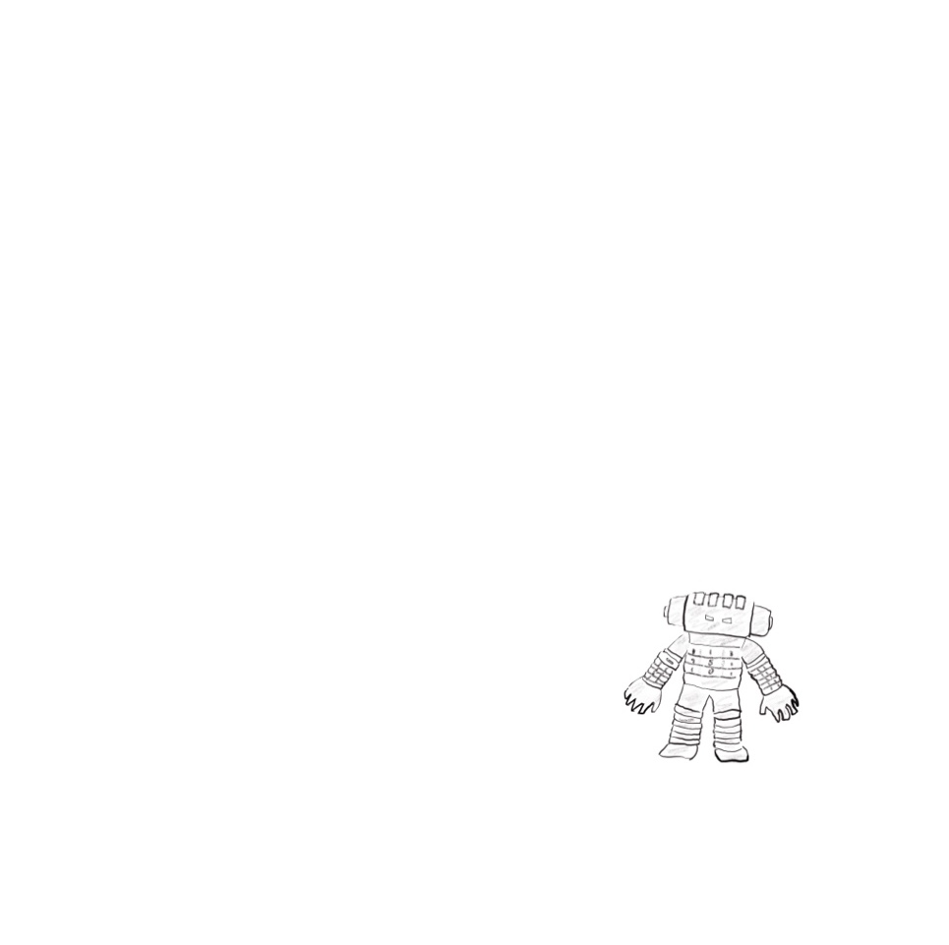

Grandpa was still going through the rest of the kit. “Hmm. No motor controller. No microcontroller. Without those, your robot isn’t going to walk or roll or do much of anything.”

I felt my excitement deflating.

Then he held up the white plastic block. “Ahhh…but this is a useful tool.”

“What is it?” I said.

“It’s called a breadboard.”

“A breadboard?”

“It’s for making circuits,” Grandpa said. “Back in the day, if an engineer wanted to prototype a circuit, he would screw components into a wooden bread-cutting board. Today we use these little plastic bricks instead, but we still call them breadboards.”

He kept going through the pile.

“You have a nice little assortment of resistors here,” he said.

He held up a piece that looked like this.

“And jumper wires.”

“And LED’s.”

“Looks like you also have a connector for a 9-volt battery, which will be helpful, and of course you’ve got the instruction booklet. You can read that if you’d like. I won’t need it.”

He tossed the instruction booklet aside.

“What can we build with all that?” I asked.

“Lots of things,” said Grandpa.

“I know how to build a robot,” I said. “I helped the 7th graders at my old school last year.”

“Yeah, but they were building with those school robot kits,” Grandpa said, dismissively. “That’s not real robotics. That’s kid stuff.”

I felt a little offended that Grandpa had just dismissed all the work the Northwood team did last year as “kid stuff.”

But also excited. Because I would love to do something cooler and better than what they were doing.

I would love to make a robot that blew their minds and upload it to the group chat.

“Tell you what,” Grandpa said. “Let’s make a deal.”

Classic Grandpa. His “deals” usually meant trading something I wanted—his wisdom, his tools, or occasionally cash—for something he wanted me to do, like chores, homework, or, one time, feeding his neighbor’s pet snake for a week.

“Before you can make a robot, you have to understand circuits.” He tapped the white plastic block, the one he’d called a *breadboard*. “This is the perfect place to start.”

“So what deal are we making?” I asked.

“You let me teach you about circuits, motors, and electronics, you do the hard work required to learn something new, and I’ll buy the parts you’re missing from this robot kit.”

This sounded like a pretty good deal to me.

“So I’m actually gonna be able to build a robot?” I said.

“In time,” said Grandpa. “But only if you promise to be patient. You have a lot to learn before you’re ready to just start making robots.”

“But I will be able to make one?”

“If you work hard enough, I don’t see why not.”

I was so excited, and at that moment, I was feeling like I’d lucked into the best $2 yard sale find ever.

I didn’t know it yet, but Dr. Kermit W. Sprocket had just dragged me into the adventure of my life.